This week the app.js was done.

App.js
This function is used to authenticate an admin by checking their email and password. If the email and password match the hardcoded values of "admin@admin.com" and "admin", respectively, then the admin is redirected to the admin page (admin.html). If the credentials are incorrect, an alert message is displayed.
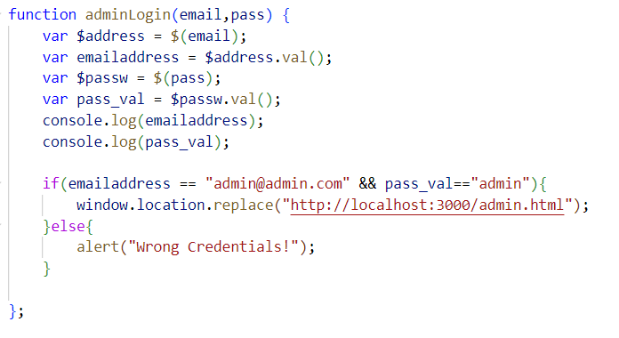
Figure: JS- admin login

This code initializes the web3Provider, contracts, account, and hasVoted variables. The init function calls initWeb3, which checks if web3 is defined and sets the web3Provider accordingly. If web3 is not defined, it sets the web3Provider to http://localhost:7545. Lastly, it calls initContract.
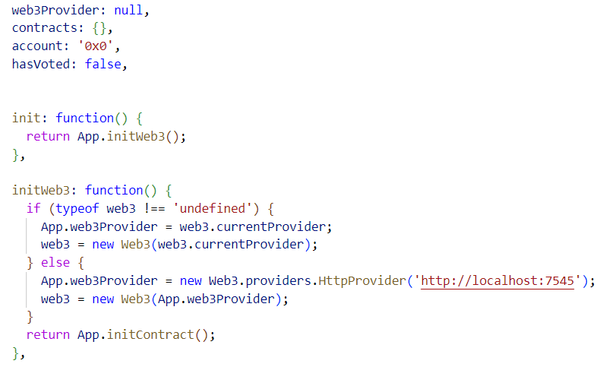
Figure: Web.js

This function initializes the contract by fetching the eVote.json file, setting the provider and listening for events. It also redirects to different pages depending on the current URL.
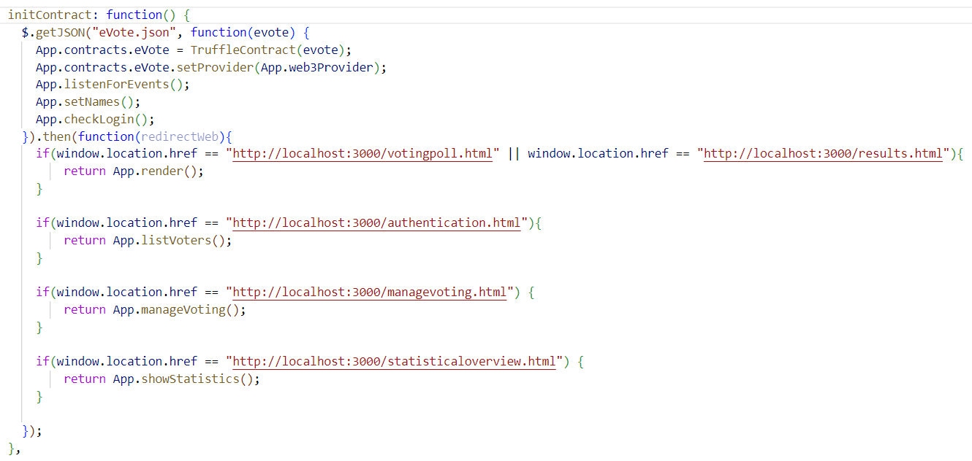
Figure 44: JS- Page Route

The function checks if a voter is logged in and shows/hides appropriate buttons. It retrieves the contract instance and voter details using the current account. If not logged in, it shows login/register/voter-in buttons and hides voter-out/results. If logged in, it shows voter-out/results and hides login/register/voter-in.
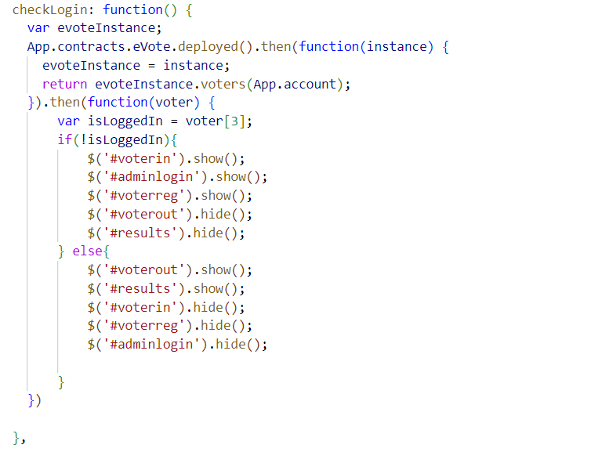
Figure: JS- Check Login

This function takes a voter's address as input, calls the voterAuth function of the deployed contract to authenticate the address, and logs the result to the console.
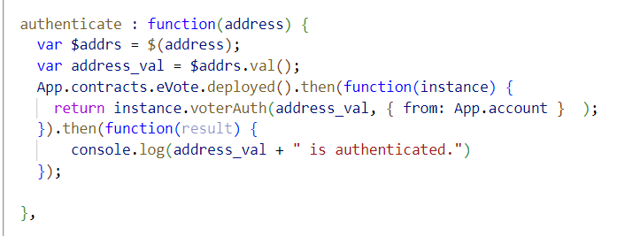
Figure: JS- Authenticate

This function manages the various stages of the voting process by showing/hiding appropriate buttons. It retrieves the instance of the deployed contract and checks the status of the voting process using different functions. It then shows/hides buttons based on the stage of the voting process.
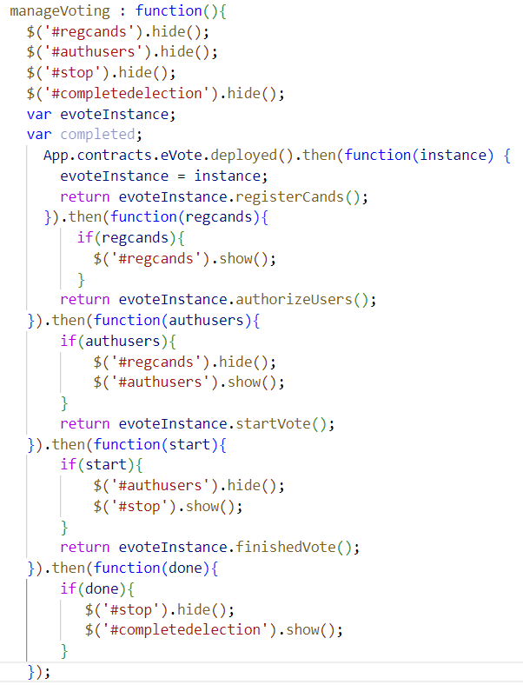
Figure: JS- Manage Voting

This function retrieves the total number of candidates and their details from the deployed contract, determines the winner, and displays the candidate results. It also checks if the user is logged in and allowed to vote, and shows appropriate messages based on that. Finally, it checks if the voting is ongoing and displays the appropriate message.
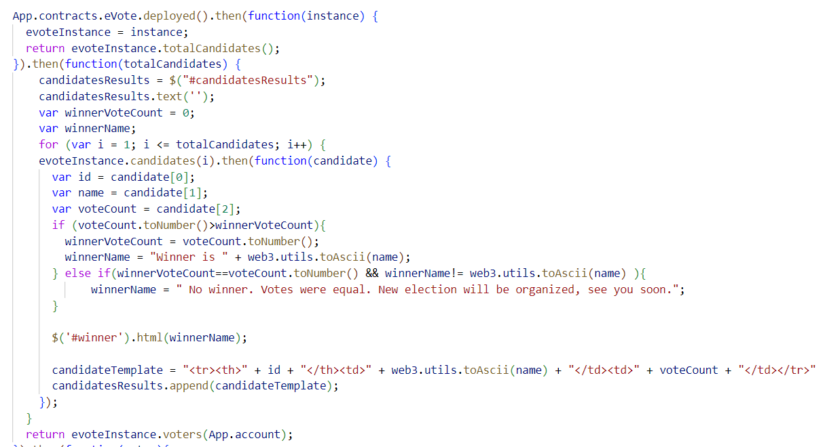
Figure: JS- Vote

The showStatistics function uses the eVote contract instance to retrieve the total number of voters and the number of voters who have already voted. It then calculates the number of unvoted voters and displays the data in a pie chart using the jqplot library.
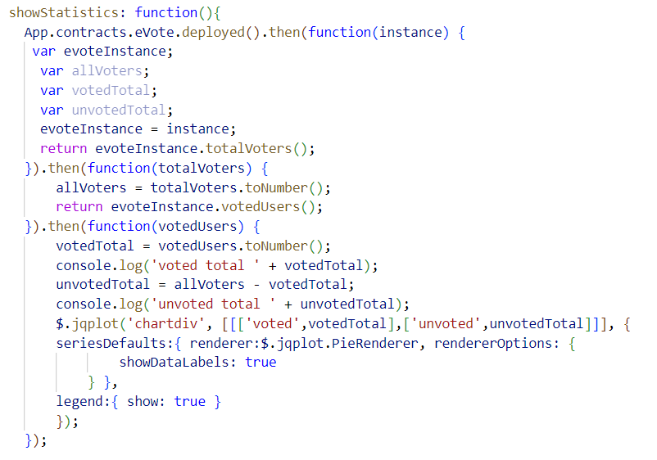
Figure: JS- Pie Char
This solidity course helped a lot.
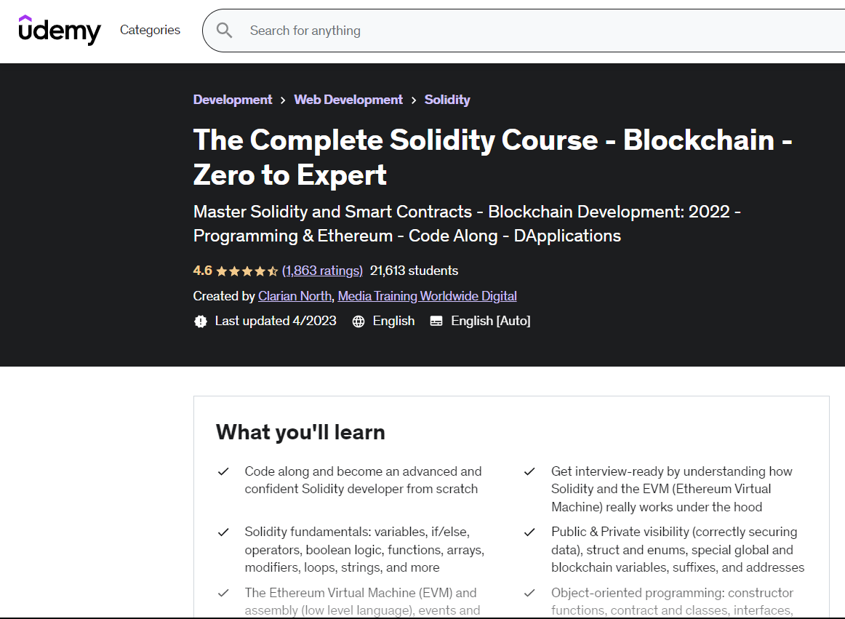

Some front-end parts were completed.
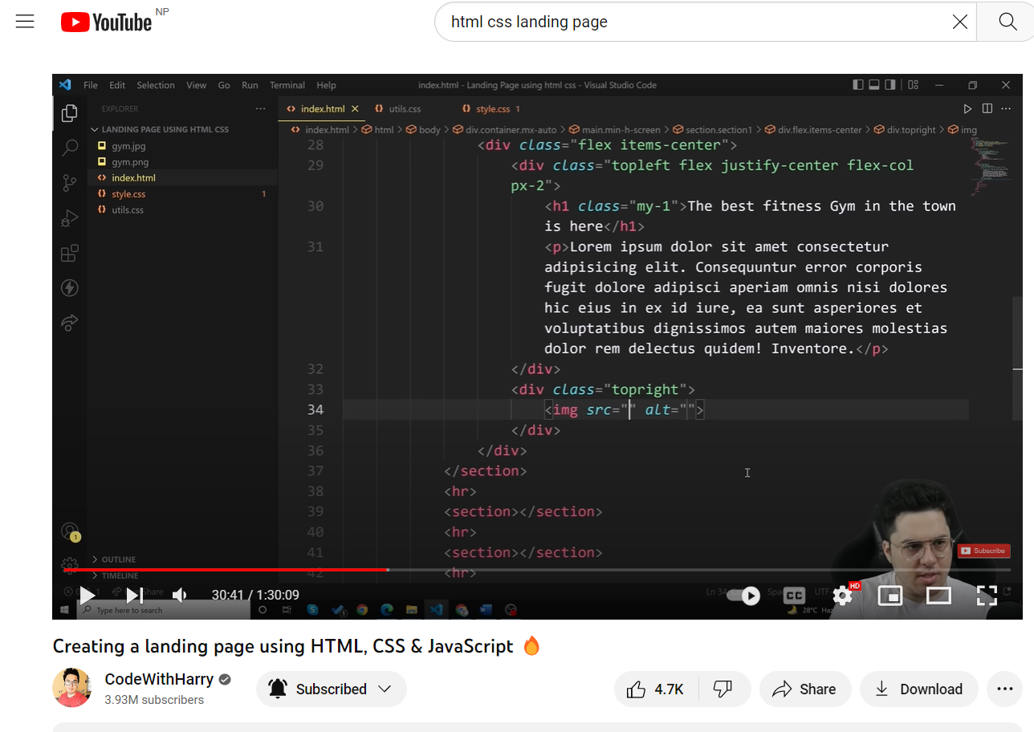

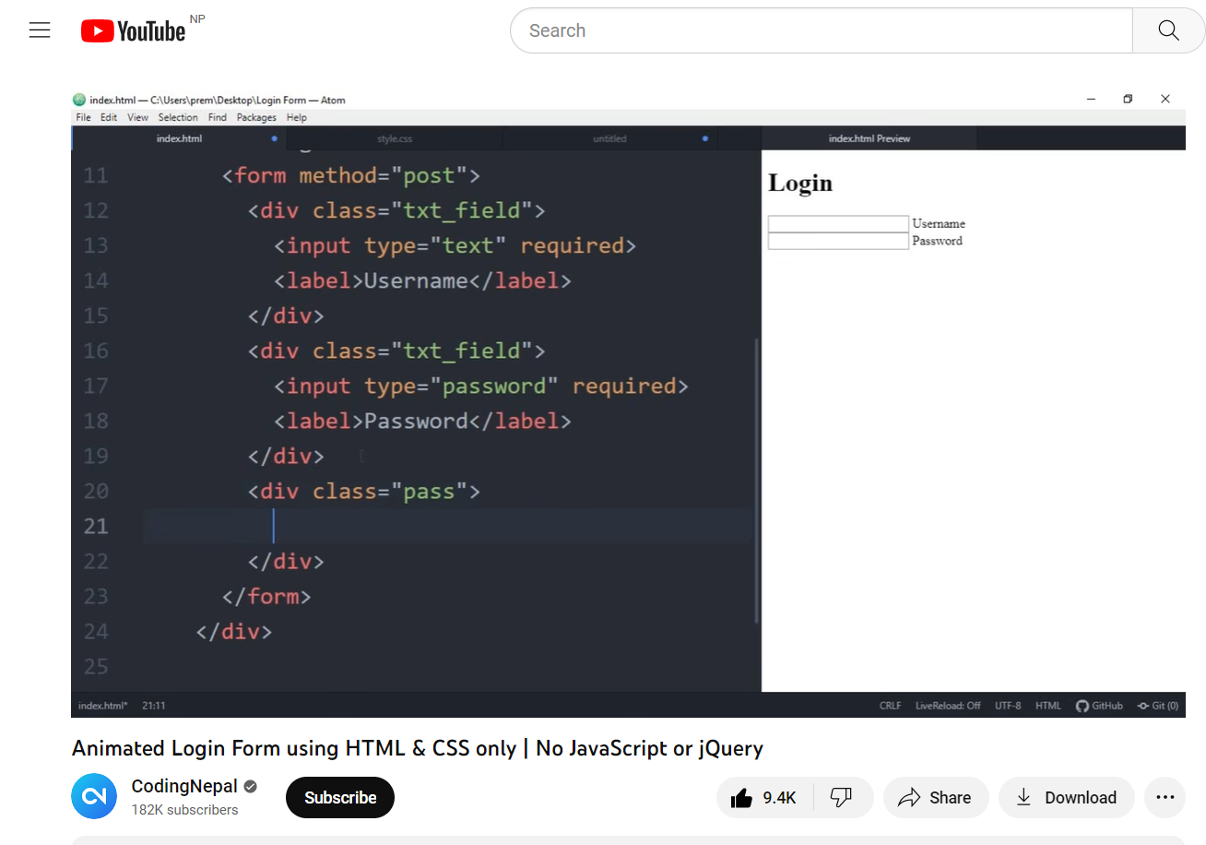

The front-end part developed are given below:
